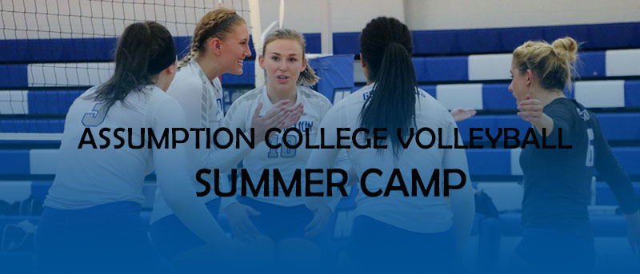

**7th-12th grade welcome – all levels of experience welcome**

Dates: Monday July 17th –Thursday July 20th

Times: 9:00am-12:00pm – registration begins at 8:30am

Location: Assumption College, Laska Gymnasium, Worcester, MA

Cost of attendance: $130

*Sibling discount available - the first child will be paid in full, each child after that will be given a $10 discount*

*Group discount available – if a school brings in more than 10 players each player from that school will be given a $10 discount*

This camp is for developing/improving skills of each player. There will be one-on-one instruction, position specific instruction, and combination drills for game-like play.

Camp director: Elyse Rowland – Head Coach

Please email Coach Elyse Rowland ([e.rowland@assumption.edu](mailto:e.rowland@assumption.edu)) with questions



Please complete the application and the liability waiver and send it back to [e.rowland@assumption.edu](mailto:e.rowland@assumption.edu) or mail to:

Assumption College Volleyball

500 Salisbury St.

Worcester, MA 01609

**Assumption College Volleyball Summer Camp**

**Name:** ______________________________________ **Phone: _____________________________**

**Name of current school: _____________________________________________________________**

**Current grade: _____________________ email: _____________________________________**

**Additional Concerns: ___________________________________________________________________**

**_____________________________________________________________________________________**

**_____________________________________________________________________________________**

**_____________________________________________________________________________________**

**\*We will have athletic trainers on staff**

**\*Players will NOT be able to participate without the liability waiver and payment received prior to or at the start of the camp**

**\*Please make checks payable to: ASSUMPTION COLLEGE VOLLEYBALL**

**\*You will receive an email confirmation once proper forms/payment have been received by the camp director – please note on the registration form if you plan to pay the day of the clinic**

**\*Refunds will be given if for any reason the camp is cancelled by the director, or if you are unable to attend – no refunds will be allowed once the player has participated in any day/part of the camp**

***Assumption College Department of Athletics & Recreation***

***Assumption College Volleyball Summer Camp***

**Acknowledgment of Risk**

*I hereby acknowledge, understand and agree that I will be engaging in activities that involve risk and the potential for serious injury including permanent disability and death. I also acknowledge that it is my responsibility to act in accordance with the rules and regulations set forth by the College.*

**RELEASE AND INDEMNIFICATION OF CLAIMS**

*In consideration for permitting me to participate in the above activity, I agree to release on behalf of myself, my heirs, representatives, executors, administrators, and assigns; Assumption College, its trustees, officers, agents and/or employees from any cause of action, claim(s) or demand(s) of any nature whatsoever which I, my heirs, representatives, executors, administrators, and assigns may now have, or have in the future against the College, its trustees, officers, agents and/or employees (except to the extent the College is negligent) on account of personal injury(s), property damage, death, or accident of any kind, arising out of or in any way related to my participation in the above activity, whether participation is supervised or unsupervised. I also agree to indemnify and hold harmless Assumption College, its trustees, officers, agents and/ or employees from any and all causes of action, claims, demands, losses or costs of any nature whatsoever arising out of my participation in the above activity*

*If the participant is under 18 years of age, a parent or guardian must sign below, certifying that that the child is in good health and fit to participate in athletic activities without restrictions and/or limitations. In case of medical emergency involving the child, the parent or guardian must understand that every effort will be made to contact them or other parent/guardian/alternate person. In the event a parent or guarding cannot be reached, the parent or guarding hereby give permission to the physician selected by the clinic to hospitalize, to secure proper treatment for, and to order injection, anesthesia, surgery or other medical procedure necessary for the child. All participants should have a written description of all existing medical conditions and/or medications they are currently taking attached with this application.*

***I have carefully read the above acknowledgement of risk, release and indemnification of claims, and understand their contents, and voluntarily sign the same as my own free act. By signing this agreement, I agree to all of the terms & conditions contained herein.***

Signature: _______________________________________________________

Print Name: _____________________________________________________

Date: __________________________________________________________

Parent/Guardian Signature *(if under 18 years old)*  _____________________________

Print Name: _____________________________________________________

Date: __________________________________________________________

***Note:*** *Assumption College & the Department of Athletics & Recreation are not authorized to provide medical, accident or health insurance. You are advised to obtain appropriate insurance on an individual basis. If you are presently insured, you should check your policy to assure yourself of sufficient and appropriate coverage.*

***DIRECTIONS:***Assumption College, 500 Salisbury St., Worcester, MA 01609

From Rhode Island: Rte.146 N; I-290 East or from Connecticut/W. Mass: I-84 East... Mass Pike (I-90) East ;Exit 10; I-290 East; Exit 17, left off ramp on Belmont St. to secondlights; at that set of lights, right on Rte. 70 (Lincoln St.); one set of lights left on Salisbury St.; the College is at No. 500.

***WEATHER:*** the clinic will be conducted as scheduled. There are no provisions for rescheduling lessons or calling students in the event of extreme weather. You may call (508)767-7236 for information whether the clinic will be held.